CHAPTER 1

* 1. INTRODUCTION:

## INTRODUCTION

##### In the fast-paced world of modern transportation, efficiency and convenience is paramount. The Railway Pass Management System, developed using PHP and MySQL technologies, represents a significant step forward in streamlining the process of issuing railway passes and providing travellers with a seamless experience.

##### This web-based solution is designed to revolutionize the way railway passes are managed and distributed. By leveraging the power of digital technology, it aims to eliminate the burdensome paperwork and time- consuming processes traditionally associated with obtaining railway passes.

The Railway Pass Management System serves as a centralized platform for railway administration to efficiently manage pass records and facilitate the issuance of passes to commuters who rely on daily railway travel. Through its user-friendly interface, individuals can apply for and receive them passes online, making the entire process both simple and fast.

By embracing this innovative system, railway administration stands to benefit from enhanced productivity, reduced administrative overhead, and improved customer satisfaction. Furthermore, passengers can enjoy the convenience of obtaining their passes with ease, enabling them to focus on their daily commute without unnecessary hassle.

The Railway Pass Management System represents a transformative solution for modernizing railway pass management, offering a seamless experience for both railway administration and passengers alike.

##### DBMS (DATABASE MANAGEMENT SYSTEM)

Database is a collection of related data and data is a collection of facts and figures that can be processed to produce information. Mostly data represents recordable facts. Data aids in producing information, which is based on facts. For example, if we have data about marks.

A database management system (DBMS) is a software package designed to define, manipulate, retrieve and manage data in a database. A DBMS generally manipulates the data itself, the data format, field names, record structure and file structure. It also defines rules to validate and manipulate this data.

A DBMS relieves users of framing programs for data maintenance. Fourth- genera- -tion query languages, such as SQL, are used along with the DBMS package to interact

with a database.

* + 1. MySQL
    2. SQL Server
    3. Oracle
    4. dBase
    5. FoxPro

##### PHP (HYPERTEXT PREPROCESSOR)

PHP is the most popular and widely used server-side scripting language for web development. It is used to make the Dynamic pages in websites. Rasmus Lerdorf was the creator of PHP in 1995. PHP codes are embedding in HTML source codes for making the page dynamic.

PHP can deal with most of the requirements in wed development like Database, File handling, String operations, Arrays, Graphics, File Uploads, Data processing etc. PHP can be used in any operating system with a web server Supports PHP. Apache web server is one of the popular web servers dealing with PHP + MySQL.

##### PROBLEM STATEMENT

The current process of managing and issuing railway passes is inefficient and cumbersome, relying heavily on manual paperwork and consuming significant time and resources. This paper-based approach results in delays, errors, and a lack of transparency in the pass issuance process. Additionally, passengers often face challenges in obtaining their passes, leading to frustration and inconvenience.

The need for a more streamlined and efficient solution is evident. Railway administration requires a modern, digital platform that can centralize pass management, automate processes, and provide passengers with a convenient and fast way to obtain their passes.

##### OBJECTIVES

The primary goal of this initiative is to

1. Reduce paper work
2. Shorten the waiting time
3. Real-Time Status Updates
4. Security and Privacy
5. Cost Reduction

CHAPTER 2

## REQUIREMENT SPECIFICATION

##### 2.1 HARDWARE REQUIREMENTS

The hardware required for the development of this project is: Processor : Intel Core i3

Processor speed :1.7 GHz RAM :2 GB

System Type :64-Bit Operating System

##### 2.2 SOFTWARE REQUIREMENTS

The software required for the development of this project is:

**Software :** XAMPP

**OS :** Platform Independent

**Programming Language :** PHP5.6, PHP7.x and SQL

**Database :** MySQL 5.x

**User Interface Design :** HTML, AJAX, JQUERY, JAVASCRIPT

CHAPTER 3

## DESIGNS

##### 3.1 ENTITY-RELATIONSHIP DIAGRAM

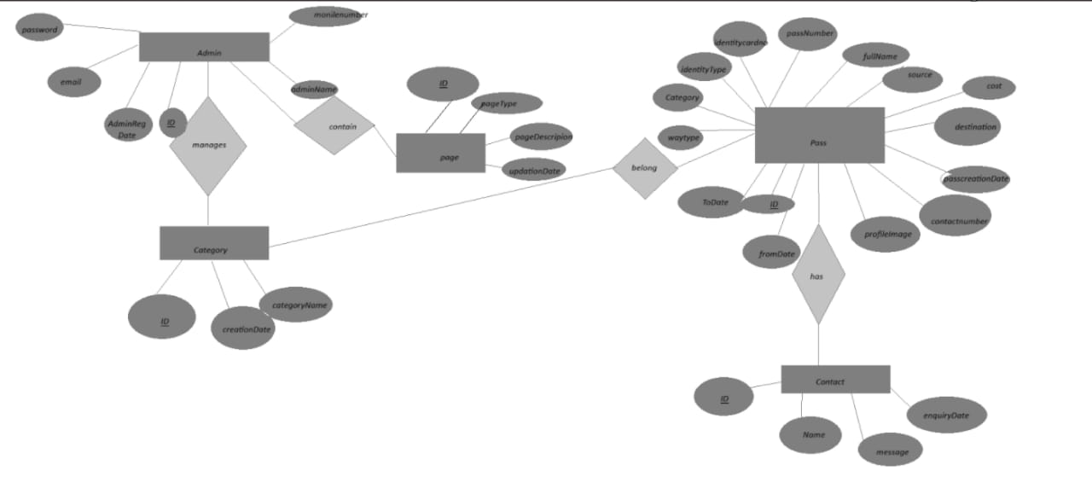

**Figure 3.1: E-R Diagram for Railway pass management**

3.2 NOTATIONS:

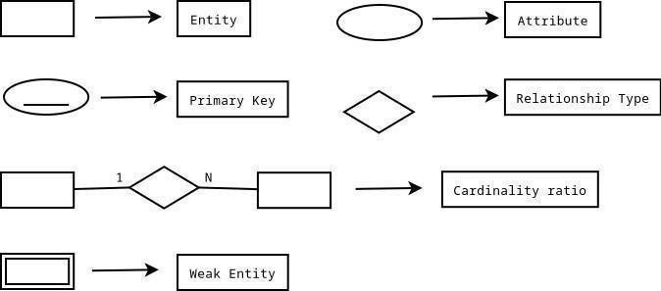

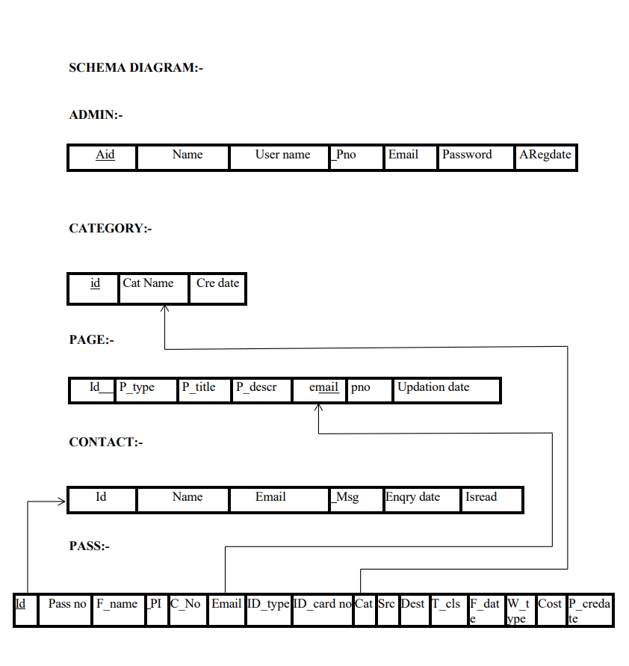

3.3

CHAPTER 4

##### DESCRIPTION

The ER Model figure shows conceptual view of the database. It works around real-world entities and the associations among them. At view level, the ER model is considered a good option for designing databases. So, let’s see each entity.

4.1 ADMIN TABLE

This entity stores the login credentials of the admin.

4.2 CATEGORY TABLE

This entity stores the information about different types or categories of railway passes available for passengers. Attributes are ID, Category Name, Creation Date

4.3 CONTACT TABLE

This entity stores the contact information of passengers. The attributes are ID, Name, Email, Message, Enquiry Date

4.4 PAGE TABLE

This entity serves as a component in managing the user interface or content displayed to users with in the system. The attributes are ID, Page Type, Page Description, Email, Mobile Number, UpdationDate

4.5 PASS DETAILS TABLE

This entity stores the pass details of the passengers. Attributes are ID, Pass Number, Full Name, Profile Image, Contact Number, Email, Identity Type, IdentityCardno, Category, Source, Destination, TrainClass, FromDate, ToDate, WayType, PasscreationDate

CHAPTER 5

## SNAPSHOTS

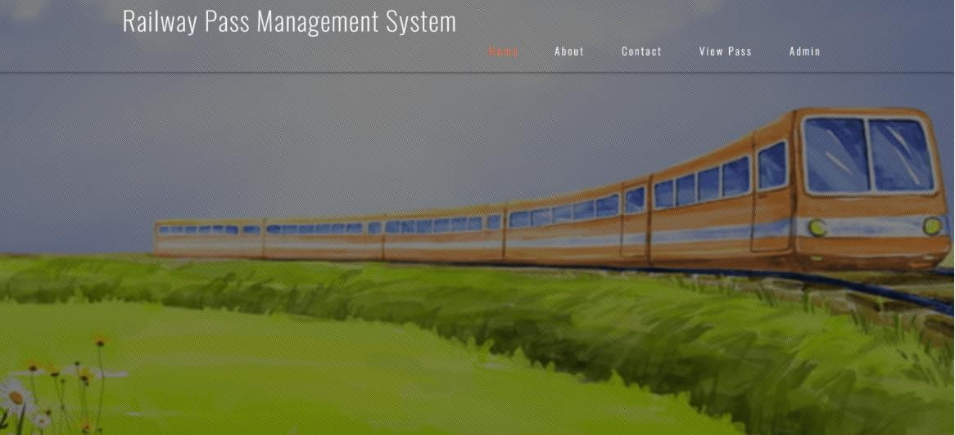

Figure 5.1: HOME PAGE

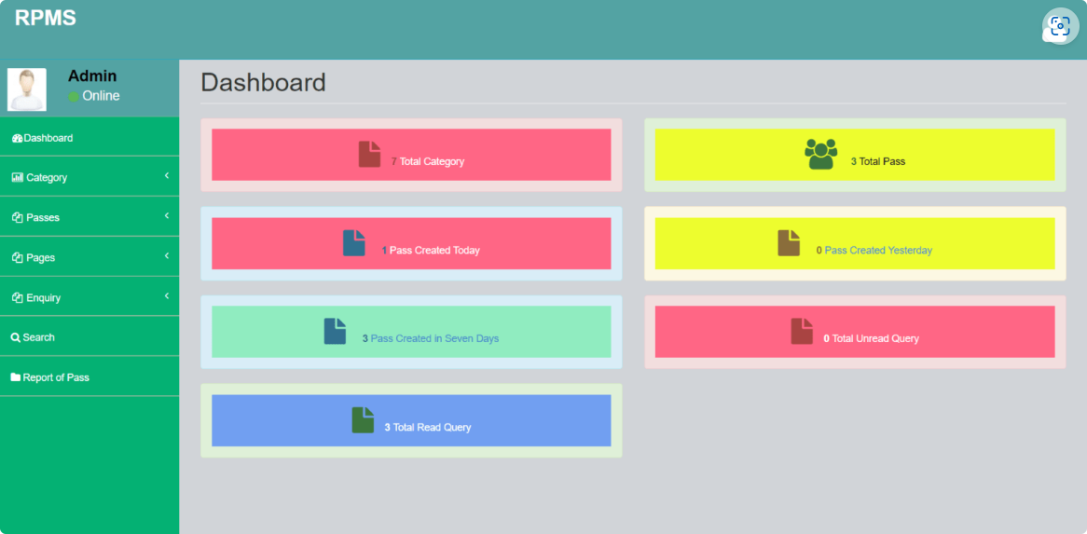

Figure 5.2: Dashboard

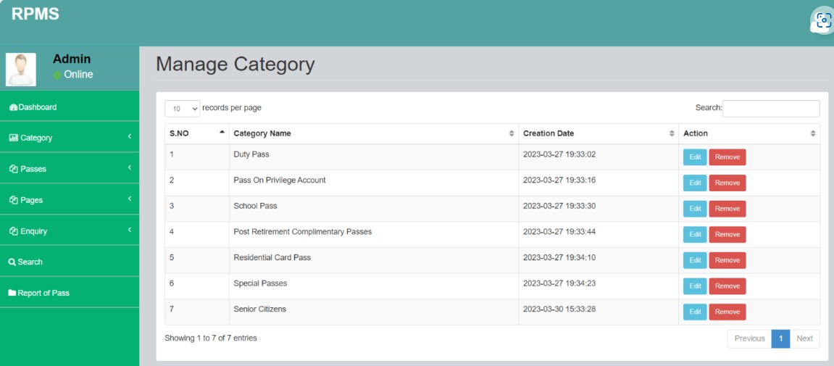

Figure5.3: Manage Category

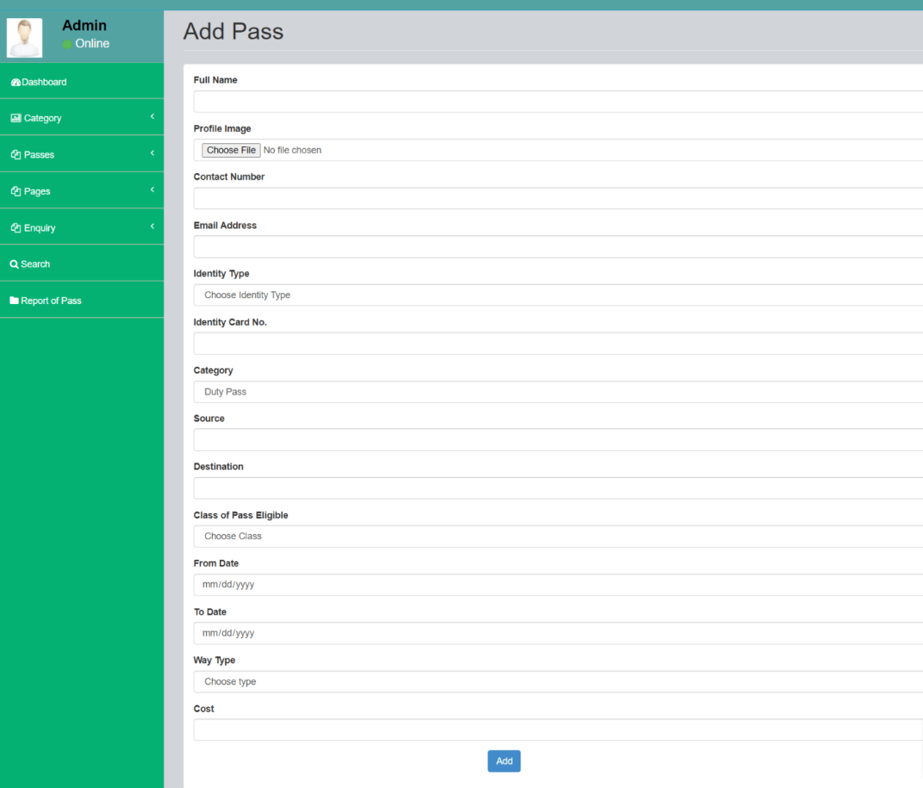

Figure 5.4: Add pass

## CONCLUSION

##### The Railway Pass Management System offers a modernized approach to pass issuance and management, facilitating a streamlined process for both passengers and railway authorities. Through its user-friendly interface, passengers can easily apply for passes, make payments online, and receive real-time updates on their pass status. This digital platform reduces the need for manual paperwork and enhances accessibility, providing a seamless experience for commuters, frequent travellers, and tourists alike. Meanwhile, railway authorities benefit from efficient administrative tools for pass categorization, pricing adjustments, and comprehensive reporting functionalities. Enhanced security measures ensure the protection of passenger data and compliance with regulatory standards, fostering trust and reliability in the system. Continuous innovation and responsiveness to user feedback will further refine the Railway Pass Management System, ensuring its effectiveness in meeting the evolving needs of passengers and maintaining operational excellence within the railway industry.